**LAB 5**

**On-line motion-based game app using the Data Processing and Motion Recognition apps we provide**

**By:**

**Sujitha Onteru**

**Sindhu Koneru**

We took Maze game to recognize the motion as this is also our project. Here we are recognizing different gestures like bottom, right, left etc. We train the data for the gestures required and generate sequence files. These sequence files are stored in SD card, at the chosen path.

Three .java files are added into the project as follows:

1. ConnectionService
2. SensorTagData
3. TestGesture

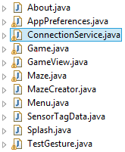

For sensor tag recognition we write code in OnLEScan method

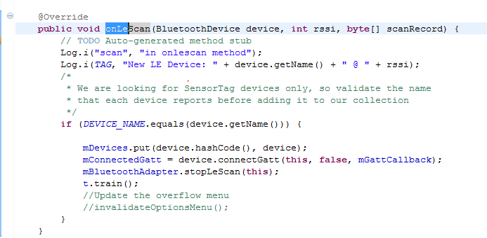

Segment file in updateAccelerometerCals function then we generate sequence fiels then testing occurs in that function.

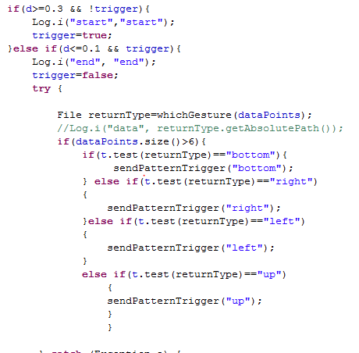

In original code we use touch event, now we have to use gestures, so we have to receive data first .So we create onResume() function to register broadcast receiver to receive data from the sensor.

Then we created Broadcaste receiver function .If we had bottom gesture onswingb is called. If we had right gesture onswingr is called. If we had left gesture onswingl is called. And correspondingly for up gesture.

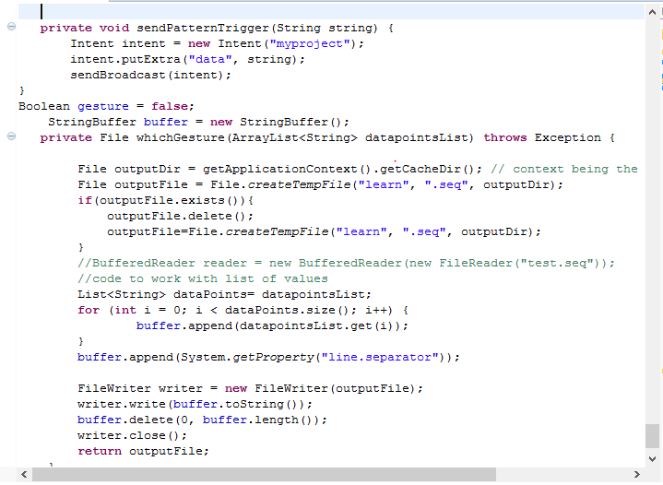

These function onswingb, onswingr , onswingl are used to give appropriate gestures in our maze game.

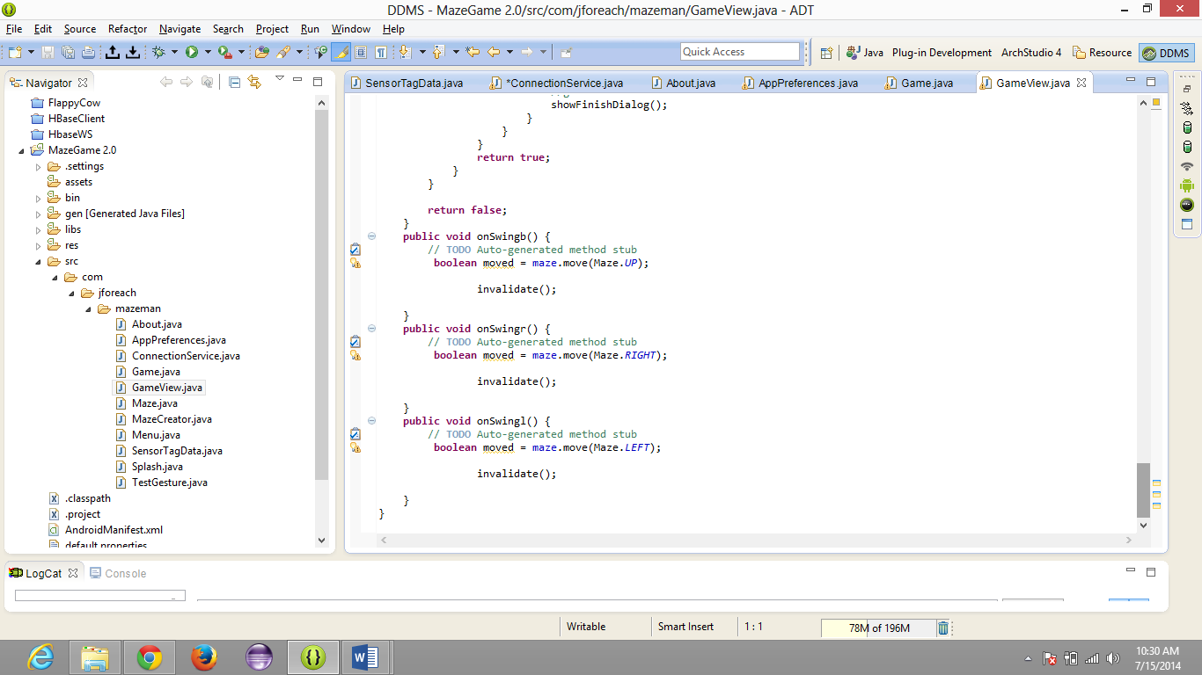

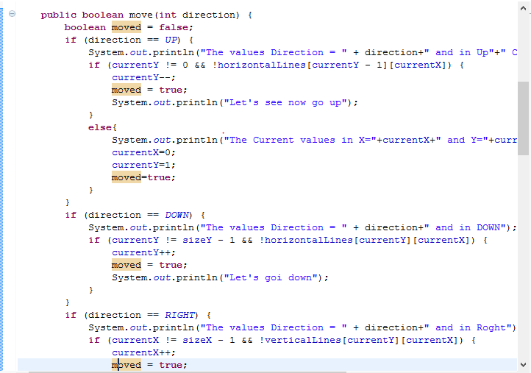

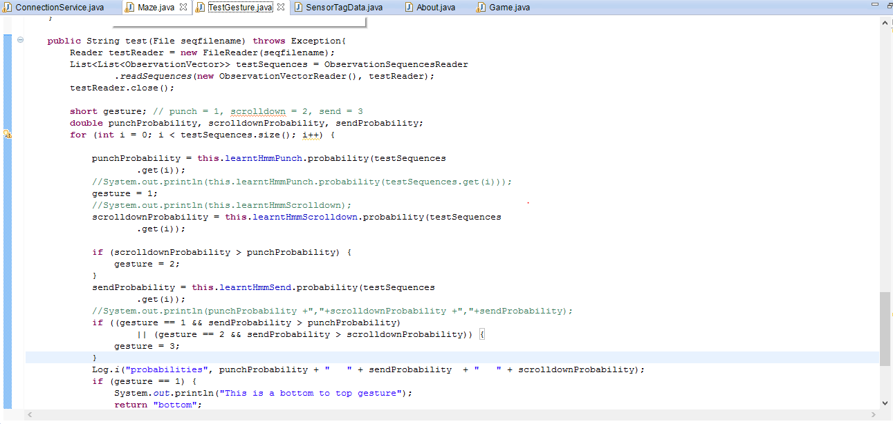

Now it is time to run the project on an intended device. We have choosen Samsung galaxy as our device.

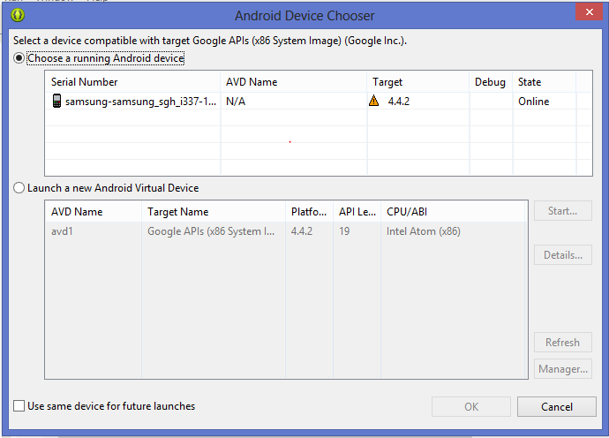

Below is an image of the logcat with valid entries.

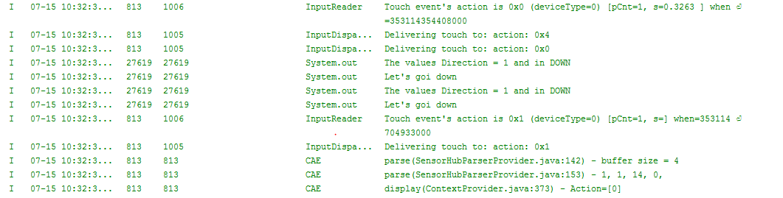

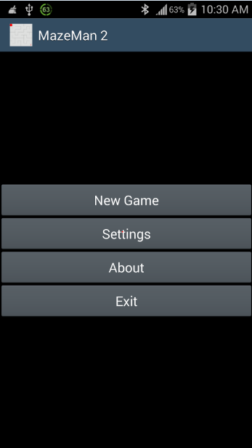 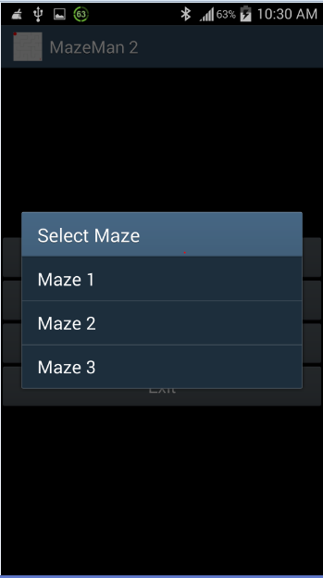

Using Sensor tag the ball is been moved from present location to 2 steps further. It looks as follows:

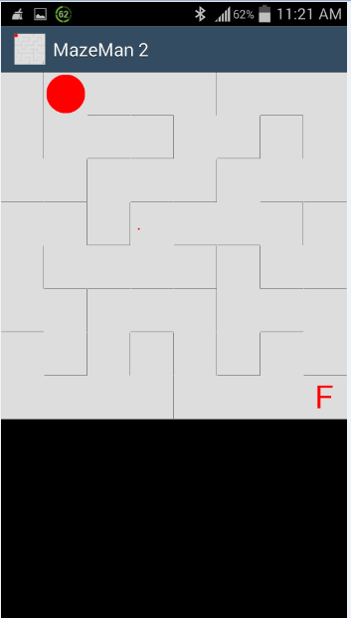 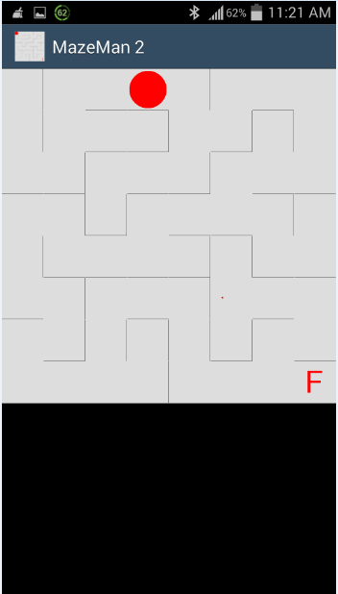

The values of catlog during the motion are as follows:

